**UCID: 2024510001 BATCH: A NAME: Atharva Vasant Angre**

**EXPERIMENT NO: 05**

**EXPERIMENT TITLE:** To implement dynamic algorithms

5.1 To implement Matrix chain multiplication

**Objective:**

1.To Implement Matrix chain multiplication

**Program code:** -

import java.util.Scanner;  
  
public class MatrixChainMultiplication {  
 static void matrixChainOrder(int[] p, int n) {  
 int[][] m = new int[n][n];  
 int[][] s = new int[n][n];  
  
 for (int L = 2; L < n; L++) {  
 for (int i = 1; i < n - L + 1; i++) {  
 int j = i + L - 1;  
 m[i][j] = Integer.*MAX_VALUE*;  
 for (int k = i; k < j; k++) {  
 int q = m[i][k] + m[k + 1][j] + p[i - 1] * p[k] * p[j];  
 if (q < m[i][j]) {  
 m[i][j] = q;  
 s[i][j] = k;  
 }  
 }  
 }  
 }  
  
 System.*out*.print("Optimal Parenthesis is: ");  
 *printOptimalParens*(s, 1, n - 1);  
 System.*out*.println();  
  
 System.*out*.println("\nDP Table (Minimum Cost of Multiplications):");  
 *printDPTable*(m, n);  
 }  
  
 static void printOptimalParens(int[][] s, int i, int j) {  
 if (i == j) {  
 System.*out*.print("A" + i);  
 } else {  
 System.*out*.print("(");  
 *printOptimalParens*(s, i, s[i][j]);  
 *printOptimalParens*(s, s[i][j] + 1, j);  
 System.*out*.print(")");  
 }  
 }  
  
 static void printDPTable(int[][] m, int n) {  
 for (int i = 1; i < n; i++) {  
 for (int j = 1; j < n; j++) {  
 if (i > j) System.*out*.print("\t");  
 else System.*out*.print(m[i][j] + "\t");  
 }  
 System.*out*.println();  
 }  
 }  
  
 public static void main(String[] args) {  
 Scanner sc = new Scanner(System.*in*);  
 System.*out*.print("Enter the number of matrices: ");  
 int numMatrices = sc.nextInt();  
 int[] dimensions = new int[numMatrices + 1];  
  
 System.*out*.print("Enter dimensions of matrix A1 (format: rows columns): ");  
 int rows = sc.nextInt();  
 int cols = sc.nextInt();  
 dimensions[0] = rows;  
 dimensions[1] = cols;  
  
 for (int i = 2; i <= numMatrices; i++) {  
 System.*out*.print("Enter dimensions of matrix A" + i + " (format: " + cols + " columns): ");  
 rows = sc.nextInt();  
 if (rows != cols) {  
 System.*out*.println("Invalid dimensions! Number of rows in matrix A" + i + " must be " + cols + ".");  
 i--;  
 continue;  
 }  
 cols = sc.nextInt();  
 dimensions[i] = cols;  
 }  
  
 *matrixChainOrder*(dimensions, numMatrices + 1);  
 sc.close();  
 }  
}

**Output:**

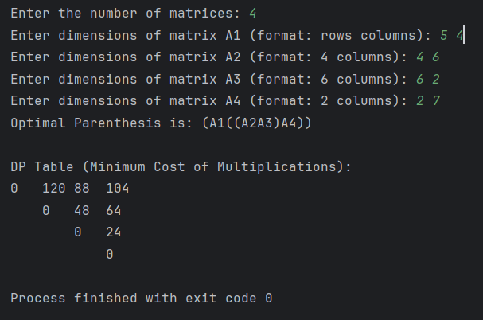

**Conclusion:**

In this practical session, I explored how dynamic programming optimizes matrix chain multiplication. The approach involves storing intermediate results in a table and evaluating different split points to reduce the total number of scalar multiplications. By taking user input and computing the optimal solution, I saw how careful planning and efficient computation can tackle complex problems effectively.